Parrallel Bore Bearing Mounting

Bearing Theoretical Data
To be completed by Fitting Personnel
Project Name:

Mounting Instructions
Bearing Number: |  |  | Bearing Position:
Shaft Inspection: Accurately measure the selected shaft
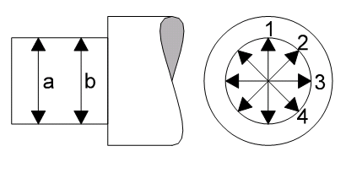
Measurement positions

 | Position
Plane | 1 | 2 |  | 3 | 4
a
b
Shaft Fit Selection: |  |  | Limit of Fit:  (Shaft Tolerance Table HR1)
Shaft Ø and Tolerance  (Recommended) |  |  | Housing Ø and Tolerance  (Recommended)
Out-of-Roundness between 1a to 2a: |  |  | Out-of-Roundness between 1b to 2b:
Taper between 1a to 1b: |  |  | Taper between 2a to 2b:
Form accuracy: Out-of-roundness and taper should not exceed half the diameter tolerance
Shaft Condition / Comments:

